Based on your requirements (Android app in Java, PostgreSQL as the database, integration with Waze, role-based functionality), here’s the general recommendation for languages, frameworks, and environments to develop your carpooling system efficiently:

Languages and Environments
- Frontend (Mobile App)
  - Language: Java (since you prefer it for Android development).
  - Environment:
    - Use Android Studio, which is the standard IDE for Android app development.
  - Libraries/Frameworks:
    - Retrofit: For API integration with the backend.
    - Glide/Picasso: For handling images efficiently.
    - Material Design Components: For creating a modern, responsive, and user-friendly UI.
- Backend
  - Language: Java (to align with the frontend development language and ensure consistency).
  - Framework:
    - Spring Boot: A popular framework for building scalable backend services with minimal configuration.
      - It provides robust support for REST APIs, security, and database integration.
  - Environment:
    - Development: Use IntelliJ IDEA or Eclipse for backend coding.
    - Deployment: Host the backend on cloud platforms like AWS, Google Cloud, or Heroku.

- Database
  - Database: PostgreSQL.
  - Environment:
    - Use pgAdmin or any PostgreSQL GUI tool for database management.
    - Host the database on a cloud service like AWS RDS or Google Cloud SQL for scalability.
  - Integration:
    - Use Hibernate (JPA) as an ORM tool for seamless integration with Java.
    - Libraries: Add PostgreSQL driver to your backend project (e.g., org.postgresql).
- API Integration
  - Third-Party API: Waze API for route optimization.
  - Libraries: Use RestTemplate (in Spring Boot) or WebClient for making HTTP requests to Waze or any other third-party APIs.
- Authentication and Authorization
  - Solution:
    - Spring Security: For role-based access control (e.g., Admin, HR Manager, Driver, Passenger).
    - JWT (JSON Web Tokens): For stateless authentication between the mobile app and backend.
  - Environment:
    - Use secure HTTPS endpoints with SSL/TLS encryption.
- Deployment
  - Mobile App:
    - Publish the app on Google Play Store.
  - Backend:
    - Use Docker to containerize your backend for easy deployment and scalability.
    - Host the backend and database on AWS or Google Cloud.
- Testing
  - Mobile App Testing:
    - Use JUnit and Espresso for unit testing and UI testing.
  - Backend Testing:
    - Use JUnit and Mockito for testing backend business logic and API endpoints.
- Version Control
  - Tool: Git.
  - Environment: Use GitHub, GitLab, or Bitbucket for version control and team collaboration.

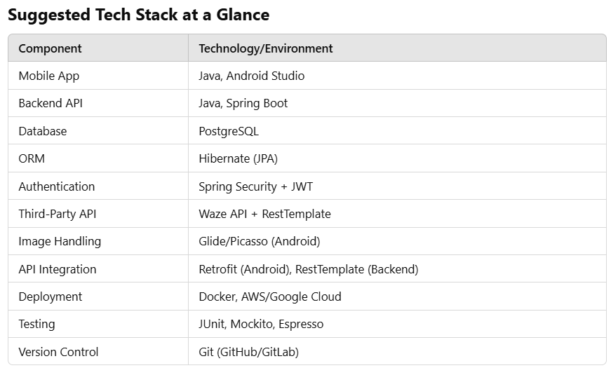

Why This Stack?
- Alignment Between Frontend and Backend:
  - Both frontend (Android app) and backend use Java, making debugging and team collaboration easier.
- PostgreSQL:
  - A reliable, open-source, relational database suitable for handling structured data.
- Spring Boot:
  - Provides scalability, a wide ecosystem, and built-in support for REST APIs and security.
- Android Studio:
  - The best tool for Android development with powerful debugging and design tools.
- Scalability:
  - The stack is modular and can easily scale with additional users and features.

